CP4282 Assignment #2 Due Thurs June 6th ( 20 marks total )

For this assignment you will create a simple mobile application which will display a top 3 list. You get to decide the theme of your app in terms of what the top 3 list is for. Some examples could be:

Top 3 video games

Top 3 food recipes

Top 3 movies

Top 3 sports

The mobile app must include 3 buttons to switch between the different items in your top 3 list. It is up to you how you layout your buttons and description of the item. Here is a sample mockup:

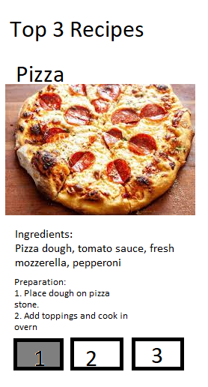

Requirements:

1. ( 5 marks)Generate a blank template project using create-expo-app and place on github version control. Please see the tutorial here for the command to create the template project: <https://docs.expo.dev/tutorial/create-your-first-app/>

Please note that you will also need to follow the steps “Install Dependencies”. Then to be able to run your project on the Android Emulator you will need to follow the following steps from the “Set up your environment” guide:

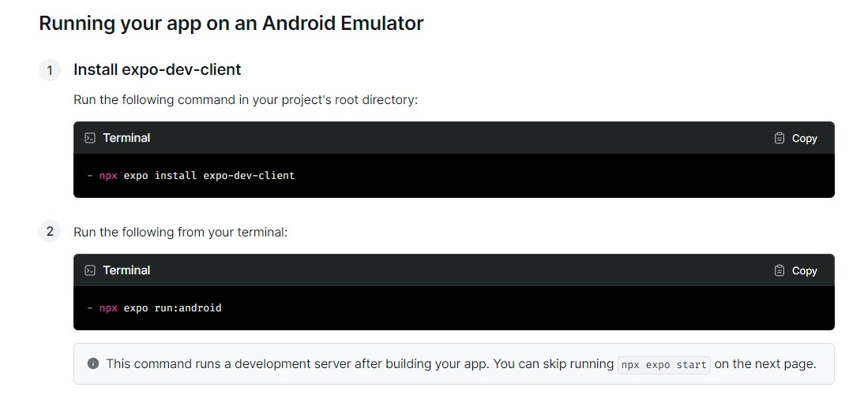

1. ( 5 marks) Create a react native component which will display the current item (either #1, #2 or #3 in the top 3 list). This component should receive a props argument and use the props to display the information for the item. The information should include 1 image. Make sure to use react-native components inside this component.
2. ( 3 marks) Create a button component which will be placed on the screen 3 times to switch between the different items. I suggest using the <Pressable> react native component for this. Please see the button created here for an example: <https://docs.expo.dev/tutorial/build-a-screen/>
3. ( 3 marks )Add the logic to handle switching between the different items when a button is pressed. You will want to use the useState hook to keep track of which item is currently selected.
4. (4 marks) Modify the button which is selected to render with a different style to indicate which item is selected.